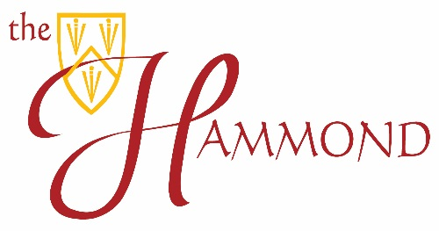
The Hammond School
GCSE Results
2020

 | No. of entries | 9 | 8 | 7 | 6 | 5 | 4 | 3 | 2 | 1
English Language | 29 | 2 | 3 | 4 | 5 | 7 | 8 | 0 | 0 | 0
English Literature | 28 | 2 | 3 | 4 | 7 | 8 | 4 | 0 | 0 | 0
Mathematics | 29 | 1 | 2 | 3 | 5 | 8 | 9 | 1 | 0 | 0
Science Trilogy* combined scores  Foundation | 34 | 0 | 0 | 0 | 0 | 13 | 17 | 4 | 0 | 0
Science Trilogy* combined scores  Higher | 22 | 1 | 3 | 3 | 6 | 9 | 0 | 0 | 0 | 0
Art | 15 | 0 | 3 | 3 | 4 | 2 | 2 | 1 | 0 | 0
Business studies | 11 | 0 | 1 | 0 | 4 | 1 | 4 | 1 | 0 | 0
Drama | 24 | 4 | 4 | 5 | 9 | 2 | 0 | 0 | 0 | 0
Food and Nutrition | 5 | 0 | 0 | 0 | 1 | 2 | 2 | 0 | 0 | 0
French | 7 | 0 | 0 | 0 | 2 | 2 | 3 | 0 | 0 | 0
German | 3 | 0 | 0 | 0 | 1 | 1 | 1 | 0 | 0 | 0
Geography | 7 | 0 | 2 | 0 | 2 | 1 | 2 | 0 | 0 | 0
History | 14 | 0 | 1 | 5 | 3 | 4 | 1 | 0 | 0 | 0
Music | 14 | 0 | 4 | 2 | 3 | 2 | 1 | 0 | 0 | 0
Religious Studies | 12 | 3 | 1 | 2 | 3 | 2 | 1 | 0 | 0 | 0
IGCSE English Literature | 1 | 0 | 0 | 0 | 0 | 1 | 0 | 0 | 0 | 0

